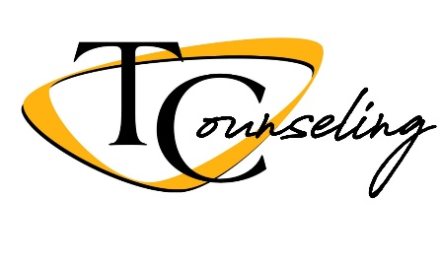

Counseling Update for Class of 2020
With the unprecedented ending of our school year and the many changes occurring as a result, the counseling department wanted to send out grade specific information to answer questions you may have. We also wanted to provide some resources/links that we thought might be useful in the next few months.
How are we going to be graded for this semester?
For this semester you will earn credit based on what grade you had as of March 11, 2020. If you were passing your class(es) you will have a CR posted as your final grade for the semester. You will also have the option of taking the letter grade as of March 11, 2020. For all students who had required class(es) that were below a 60% as of March 11, you will have the opportunity to work with your teacher to bring that grade up to a passing grade and receive credit (CR). This work will be done through Google Classroom and/or packets that will be starting April 20th until you get to a 60%.
Grades as of March 11
- Passing grade and happy with grade: Take CR on transcript, no further action required.
- Passing grade and happy with grade: Take Letter Grade on transcript, click on and fill out this Choosing a Letter Grade form by May 21, indicating what class(s) you want a letter grade.
- Failing grade: Work with teacher(s) to get up to a 60% to earn credit for graduation
- ***If you are planning on playing division I or II athletics in college please contact Mrs. Renner or Mrs. Kik for important information on grading choices.

***The week of April 13th - 17th: Mr. Goheen, Mr. Williams, Mrs. Renner, and Mrs. Kik will be contacting students via phone that have failing grade(s) in class(es) required for graduation. In the phone call we will discuss a plan for successful completion. We will also be sending out congratulations emails April 13th - 17th if you have successfully completed your high school requirements as of March 11th. Please check your email regularly.
When and how should I send my final transcript to the college I am attending in the fall of 2020?
You should login to your Parchment account (www.parchment.com) and order your final transcript to be sent to the college you are planning on attending between June 1 - June 20. After June 30th the system will begin charging you money to send your transcript.

When will my TCHS Google account and email be disabled?
Your TCHS Google account will be disabled on July 1st. Please create a new Google account and begin copying and pasting any important documents to your new account prior to July 1st.
Can I still apply for the local scholarships?
Yes, please continue to send in your applications. The deadline is April 24th for many of them. Counseling Web Page - Scholarships To make it easy, just send your applications to wkik@tricountyschools.com to get them to where they need to go.
Will there be a graduation ceremony?
As of today administration is planning on working with your class officers and class advisors to develop a plan for a graduation ceremony for the class of 2020. When, what, and how is yet to be determined; we will keep you posted.
What if I am concerned about my mental health?
If you NOTICE something different in the way you are thinking, feeling, or acting and need some support, please reach out to someone you trust (a parent, teacher, coach, pastor, counselor). Sometimes just telling someone how you are feeling or thinking can be enough. We also attached some links that could also help, please use them as needed:
What is Depression?
3 Relaxation Skills
Behavioral Activation Ideas
Healthy Thinking
Self-Care for Students COVID-19
Emotional Wellbeing During COVID-19
Suicide Prevention Lifeline
We are here to answer any and all questions! Please do not hesitate to contact us:
Mr. Goheen tgoheen@tricountyschools.com
Mr. Williams jwilliams@tricountyschools.com
Mrs. Renner arenner@tricountyschools.com
Mrs. Kik wkik@tricountyschools.com

